Assignment – 3

Name : Anjali Hingu

PRN : 2020033800098732

Assignment 3 question 1:

class Divide

{

static void Main(string[] args)

{

int a, b; /\* here a is numerator and b is denominator \*/

int ans, rem;

float res,a1,b1;

Console.WriteLine("please enter the numerartor:");

a = Convert.ToInt32(Console.ReadLine());

Console.WriteLine("please enter the denominator:");

b = Convert.ToInt32(Console.ReadLine());

ans = a / b;

rem = a % b;

Console.WriteLine("integer division result = " + ans + " with a remainder " + rem);

a1 = Convert.ToSingle(a);

b1 = Convert.ToSingle(b);

res = a1 / b1;

Console.WriteLine("floating point division result=" + res);

Console.WriteLine("the result of mixed fraction is " + ans + " " + rem + "/" + b);

}

}

Output:

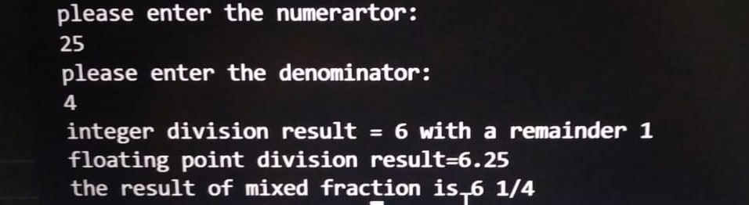

Assignment 3 question 2

class Program

{

public static void Main(string[] args)

{

string str1, str2;

Console.WriteLine("Enter a string");

str1 = Console.ReadLine();

Console.WriteLine(str1);

Console.WriteLine("entered string:" + str1 + "length of string:" + str1.Length);

int l = str1.Length;

if (str1[l - 1] == '.')

{

Console.WriteLine("declarative sentence");

}

else if (str1[l - 1] == '?')

{

Console.WriteLine("interrogratory sentence");

}

else if (str1[l - 1] == '!')

{

Console.WriteLine("exclamatory sentence");

}

else

{

Console.WriteLine("entered string is not a sentence");

}

Console.WriteLine("enter first and last name:");

str2 = Console.ReadLine();

int l2 = str2.Length;

int index = str2.IndexOf(" ");

if (index == -1)

{

Console.WriteLine(str2);

}

else

{

string fname = str2.Substring(0, index);

string lname = str2.Substring(index + 1, l2 - index - 1);

Console.WriteLine(lname + "," + fname);

}

}

}

Output:

